TASK 3

Three phase motor connected to full-voltage magnetic starter controlled by two stop and two start push button station

Power Circuit

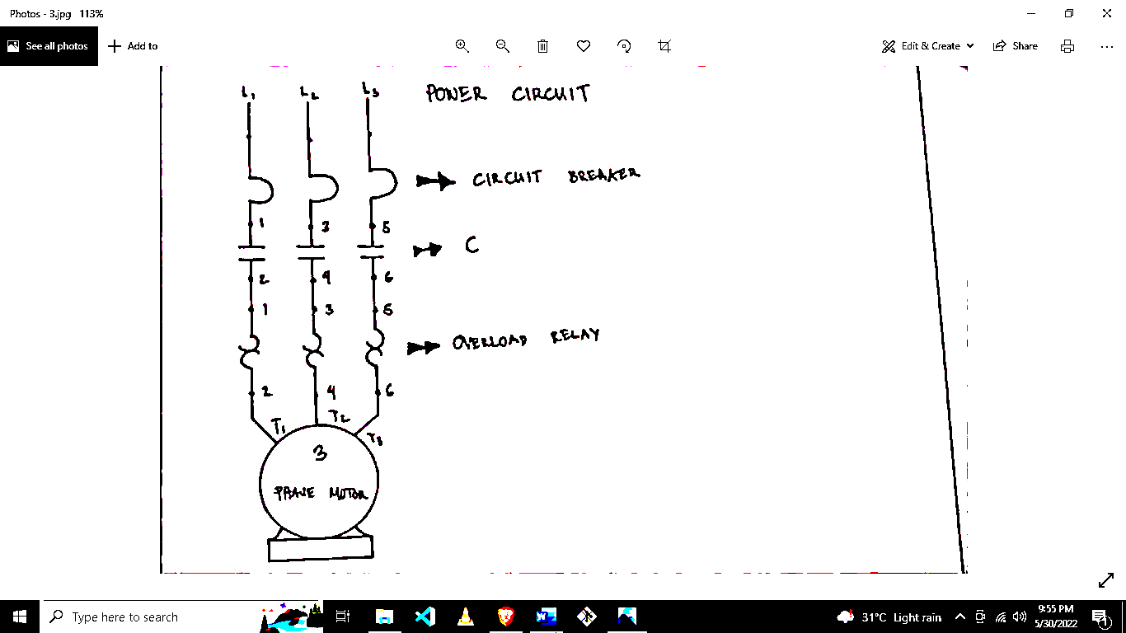

Circuit Breaker

C

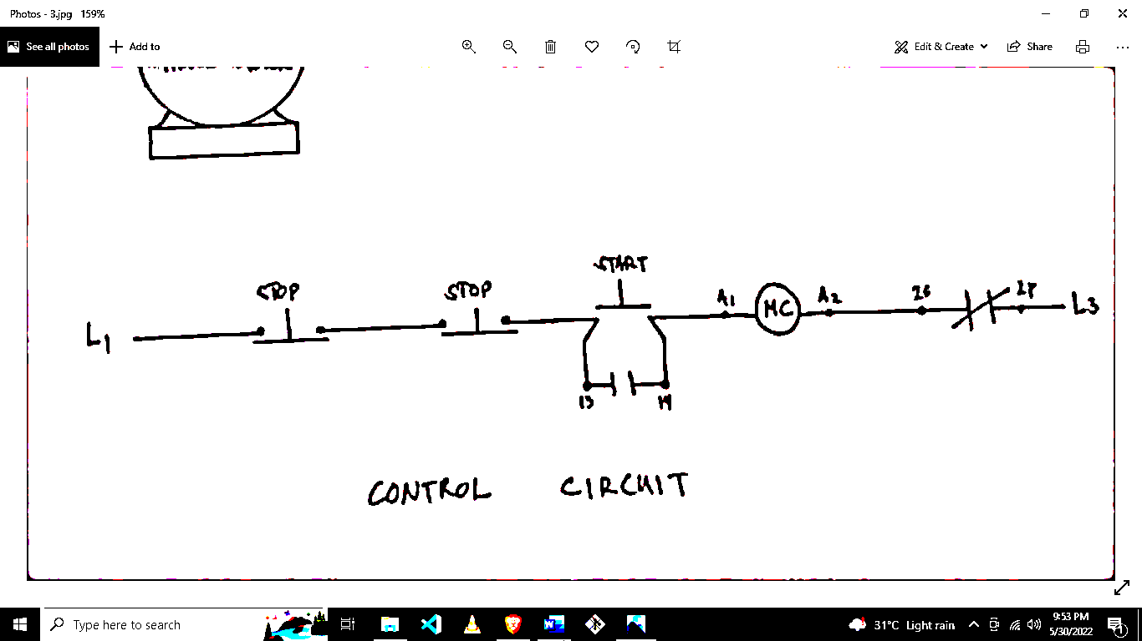

Overload Relay

Control Circuit